|  |
| --- |
| RISK (ASSESSMENT AND MITIGATION)  CLUB NAME:  Nottingham Vikings Ball Hockey Club |

|  |  |  |  |  |  |  |
| --- | --- | --- | --- | --- | --- | --- |
| WHAT ARE THE HAZARDS? | WHO MIGHT BE HARMED? | CONTROLS | ACTIONS TO MITIGATE RISKS | WHO NEEDS TO CARRY OUT THE ACTION? | WHEN IS THE ACTION NEEDED BY? | ACTION BY CLUB |
| Contracting or spreading coronavirus by not washing hands or not washing them adequately | PLAYERS  COACHES / MANAGERS  OFFICIALS  SPECTATORS | * Read guidance on cleaning, hygiene and hand sanitiser. * Third party indoor venues hired should provide water, soap and drying facilities at wash stations * Provide information on how to wash hands properly * Hand sanitiser available for outdoor play and for players to use before and after training/games. | * Put in place monitoring and supervision to make sure people are following controls * Put signs up to remind people to wash their hands * Provide information about when and where they need to wash their hands * Identify if and where additional hand washing facilities may be needed * If people can’t wash hands, provide information about how and when to use hand sanitiser * Identify how you are going to replenish hand washing/sanitising facilities * Make sure people are checking their skin for dryness and cracking and instruct them to report this if a problem develops. * Ensure payment is conducted by bank transfer and not cash-in-hand | Match/Tournament organisers  Club managers | Before any training, match or tournament. | 1. **HAND SANITISATION WITH ALCOHOL BASED ANTI-BACTERIAL WASH.** Hand sanitisation with alcohol based anti-bacterial wash will be made available on the table immediately before the sports hall entrance point, and in the hall (separately in both pods, if two pods are in use). Guidance for appropriate use is to be printed, laminated and placed prominently and adjacent to the sanitising station at the entrance to the hall. A sign will be positioned stating that everyone entering the hall must sanitise their hands with the antibacterial gel provided. DONE: (See APPENDIX I) 2. **WASHING & DRYING FACILITIES:** A separate male and female toilet is available next to the Gymnasium. Each has full washing and hand drying facilities. Anyone using the toilet facility must adhere to the one-way system indicated on the floor and wall signage. DONE: (See APPENDIX I) Hand-washing instructions will be provided and displayed prominently on walls in both male and female toilets. They will also be instructed to use anti-bacterial gel upon re-entering the hall. DONE: (See APPENDIX II) 3. Check to ensure that Clifton Sports Hall has running water (hot and cold) and washing facilities with drier . DONE. See above.. Confirmed 22 September 2020. 4. Make sure wash stations have laminated signs with hand wash instructions. Laminated posters to be added to wall adjacent to male and female cleaning stations and anti-bacterial wash station. DONE: (See APPENDIX II) 5. Club to purchase sanitiser bottles and have spares ready to replenish inventory when exhausted. A Checklist will be maintained to ensure that a) equipment has been sanitised before and after use and b) To maintain an appropriate inventory level of sanitiser at all times. DONE: (See APPENDIX III) Coach Benny has also acquired stock of sanitiser in readiness (2 Oct 2020) 6. It is the responsibility of the Coach (and Assistant Coach if a second pod is active) to ensure that sanitisation has been completed on all items listed. Alcohol gel will be provided by the club and paper towels will be used to wipe surfaces (also provided by the club). Used paper towels and empty gel containers will be disposed of in the designated waste bins provided by (and emptied by) the Sports Facility. There is one bin per pod. DONE: (See APPENDIX IV) 7. Players will be informed that they should make the coach or assistant coach aware of any skin problems, such as cracking and / or dryness. This instruction is contained in the hand sanitising poster. DONE: (See APPENDIX I) 8. Players must pay for their sessions in advance via bank transfer to the Club Account. Cash-in-hand payments are to be avoided to minimise contact and potential cross-contamination between pods. This information, along with bank transfer detail, will be added to an information pack provided to all players. DONE: (See APPENDIX V) 9. A water fountain positioned in the foyer will have added instruction stating that users of the fountain must use anti-bacterial hand sanitiser before and after using the fountain to avoid surface contamination of the water fountain button. DONE: (See APPENDIX IX)   **UPDATE: This fountain has now been completely decommissioned. Should the fountain be used again during Covid-19, the above restrictions will apply.** |
| Contracting or spreading coronavirus in common use high traffic areas such as canteens, corridors, rest rooms, toilet facilities, entry/exit points to facilities, lifts, changing rooms and other communal areas | PLAYERS  COACHES / MANAGERS  OFFICIALS  SPECTATORS | Identify:   * areas where people will congregate, eg rest rooms, canteens, changing rooms, reception, meeting rooms, smoking areas, etc * areas where there are pinch points meaning people can’t meet the social distancing rules, eg narrow corridors, doorways, customer service points, storage areas * areas and equipment where people will touch the same surfaces. * areas and surfaces that are frequently touched but are difficult to clean * communal areas where air movement may be less than in other areas, with no opening windows or mechanical ventilation   Agree the combination of controls you will put in place to reduce the risks. This can include but is not limited to:   * limiting the number of people in rooms so that social distancing rules can be met, eg have maximum occupancy numbers for areas * agree with venues one-way systems in corridors or regularly used pedestrian traffic routes to manage the flow of people moving around and to allow social distancing rules to be met * put signs up to remind people to wash and sanitise hands and not touch their faces. | * Put in place monitoring and supervision to make sure people are following controls put in place, eg following hygiene procedures, washing hands, following one-way systems * Players and officials wear a mask at all times while not playing/officiating. * Coaches, managers and spectators wear a mask at all times. | Match/Tournament organisers  Club managers | Before any training, match or tournament. | 1. Players are only to proceed to the hall at the designated start time for each pod (if 2 pods are operating). If the session start time is 7.00pm, then pod 1 will be instructed to enter the hall at exactly 7.00 pm and pod 2 shall enter at 7.05 pm. It is likely that the hall will be in use until 7.00pm by other group sports, so earlier entry will not be possible. Players are not permitted to wait in the foyer area or mingle, if they arrive early. Instead they should remain in their car or socially distance outside of the venue. This information will be added to an information pack provided to all players. DONE: (See APPENDIX V) 2. On exiting the hall, each pod has its own designated exit point. To minimise interaction between the two groups, players should exit from pod 1 first. Followed by pod 2. The coach and assistant coach will manage this process. This information will be added to an information pack provided to all players. DONE: (See APPENDIX V) 3. Players will be instructed as to which pod they will belong to from the commencement of indoor training sessions during BHUK phase 3. Players will remain in their designated pods for all subsequent weeks, until the government guidance changes or relaxes sufficiently to allow interaction (i.e. BHUK Phase 4, 30 people). Until then, players may not change or swap pods. This information will be added to an information pack provided to all players. DONE: (See APPENDIX V) 4. Players should be instructed to put on kit (socks, tape, pads etc) only once in the main hall. They will not be permitted to ‘kit-up’ in the foyer. This information will be added to an information pack provided to all players. DONE: (See APPENDIX V) 5. **Spectators are not permitted at any time** in the hall or in the foyer area. Unfortunately, this includes parents and friends. Instead they must remain in their cars or make alternative arrangements to go off-site and wait (e.g. local pub or café). This information will be added to an information pack provided to all players. DONE: (See APPENDIX V) 6. Fire doors will be opened during training to increase air-flow through the hall. There is a set of doors at each end of the halls which will provide ventilation for both pods. However, the large fans at the far end of the hall will be disabled to prevent excessive transmission of air / water particles from pod to pod. DONE: (See APPENDIX VI) 7. A one-way system will be communicated via an information pack and on laminated signage at the hall entrance instructing players on how they should enter and exit the hall, as well as how to access toilets. In essence, there is only one way into the hall, and players will not be permitted to exit via the entrance doors. Instead they must exit the hall via their designated fire doors (if in pods) and walk around the external perimeter and re-enter the hall from the main entrance. DONE: (See APPENDIX VII) 8. If 2 pods are operating, then the hall will be divided into 2 areas. A dividing curtain will be used to split the hall equally into two equally sized zones. The Coach or a member of pod 1 will be responsible for extending the curtain. The foot of the curtain contains an opaque, solid mesh material to the height of an average person and netting above that. This will prevent water particles being exchanged across the divide at player level, or balls from inadvertently crossing zones. Players will not be permitted to cross the curtain from pod 2 to pod 1, or vice versa, at any time during training to confer or chat. Players from both pods will also have to exit via their designated fire door to avoid the excessive crossing through the pod 1 area to access the door (which will be an entrance-only door). Entry from the toilets back through the hall entrance should be limited, but will involve a short passage through pod 1’s zone for players re-joining pod 2. Players from pod 2 should walk close to the wall, maintaining a 2 meter + distance from players in pod 1. The coach will agree drills with the assistant coach in advance of the training sessions. DONE: (See APPENDIX VIII) 9. The only exception to the above rule will be in the event of injury, where the player struggles to walk or requires emergency services intervention. Players will be helped off-court by members of their own pod or members of the emergency services via the most expedient route (the main hall entrance). Play will cease on both sides of the court until the player has been removed and all players from both pods should practice 2 meters + social distancing from the injured player and player(s) / emergency staff assisting the injured player off court. 10. The dimensions of the hall, when divided into two zones, to accommodate 2 pods will be 15 m x 18 per zone, providing adequate space for 6 players to conduct exercise and training routines, whilst maintaining reasonable distance during play. This area equates to approximately the size of half a netball court. DONE: (See APPENDIX VIII) 11. During training, the coach and assistant coach (where 2 pods) will be player / coaches, and therefore will not be required to wear face masks as they will partake in play. They will also make up the maximum 6 members of each pod. |
| Contracting or spreading coronavirus through travelling to venues if they do not live with one another. | PLAYERS  COACHES / MANAGERS  OFFICIALS  SPECTATORS | Provide advice on the risks of travelling to venues with people from outside their household. | * Advise teams/players to avoid this risk where possible. * If unavoidable players and officials wear a mask at all times while travelling. | Match/Tournament organisers  Club managers | Before any training, match or tournament. | 1. Vikings to prepare a handout and/or social media message to be communicated to all players advising them on car-sharing practices and risks of travelling with players outside of their household.). This information will be added to an information pack provided to all players. DONE: (See APPENDIX V) |
| Should an infection come to light subsequent to training/matches/tournaments come to light, track and trace is not possible. | PLAYERS  COACHES / MANAGERS  OFFICIALS  SPECTATORS | Track and trace mechanism in place | BHUK to provide tool to clubs.  Managers to keep track and trace information up to date at all times. | BHUK to provide.  Managers to utilise. | Before any training, match or tournament. | 1. The Covid-officer(s) will continue to record the attendees in the existing track & trace log held on nottmvikings.com. Contact details will continue to be held by the Coach only (all contact info is confidential and is not shared or published by the head coach). DONE: (See APPENDIX X) 2. Should a player become ill, demonstrating symptoms of Covid, they shall leave the hall immediately, maintaining a 2 meter + distance. The information pack provided to players will outline what the main symptoms are to be aware of. They shall also be responsible for immediately informing the coach or assistant coach of their situation. |
| Contracting or spreading coronavirus by not cleaning surfaces and equipment. | PLAYERS  COACHES / MANAGERS  OFFICIALS  SPECTATORS | Fixed furniture, fixtures and fittings – ensure venues provide assurances that regular and sufficient cleaning regimes are in place.  Player protective equipment – is never shared and cleaned after every usage.  Player protective equipment remains on while the game is in progress  Goal posts – cleaned prior/post every usage  The ball – is never picked up with a bare hand. The ball should also be sanitised after every game.  Officials should wear surgical gloves during the game in order that they can pick up the ball and reposition the goal as required. Gloves to be correctly disposed of after each game. | Players will need to ensure they have sufficient supplies of anti bacterial spray/wipes for equipment that cannot be washed.  Match/tournament organisers will need to ensure they have supplies of anti bacterial spray/wipes to clean goal posts & balls, and surgical gloves for officials. |  |  | 1. Benches and Goals used in the sports hall must be cleaned before and after each practice with anti-bacterial wipes or anti-bacterial gel and disposable paper towels. A checklist will be employed to confirm satisfactory completion of these tasks at each session, as well as the sanitising of balls, markers, cones and any other equipment used or loaned. DONE: (See APPENDIX III) 2. Message via handout / social media to remind players not to share equipment or handle balls without hockey gloves. 3. Players shall keep gloves on during the duration of the game, including any exercises (4-walls, suicides, press-ups etc) 4. Goals to be carried to the hall by two people maximum and should be cleaned before and after each session. 5. Hockey balls will be sanitised by the coach after every session. 6. The Coach should wear gloves if handling the ball during face-offs during game play etc 7. This information will be further detailed in an information pack provided to all players. DONE: (See APPENDIX V) |
| Contracting or spreading the virus by not social distancing | PLAYERS  COACHES / MANAGERS  OFFICIALS  SPECTATORS | Follow Government or venue specific guidelines on social distancing. | * Ensure advice on Government or venue specific guidance on social distancing is understood. * Limit or disallow attendance by non essential people (e.g spectators). * Players and officials wear a mask at all times while not playing/officiating. * Coaches, managers and spectators wear a mask at all times. | Match/Tournament organisers  Club managers | Before any training, match or tournament. | 1. Friends and family are not permitted to observe from the court of from the foyer area. This is a rule imposed by the Sports Centre and will be observed by the Vikings BHC. 2. Guidance notes on one-way systems to optimise social distancing, and direct / staggered entry times to the hall (when working in pods) will be communicated as detailed in earlier sections. |
| Game play | PLAYERS | Some forms of training (that do not mimic competitive games) is possible while social distancing, as described in Phase 1 of the table in section 3.4.  It is not possible to amend the rules for competitive games (or training that mimics competitive games) in order to preserve social distancing. All phases of the game include proximity of 0-1 metres, face to face contact, for 3 or more seconds. | Training activities that preserve the principles of social distancing are described in Phase 1 in the table at section 3.4 above.  While competitive games would naturally include proximity of 0-1 metres, face to face contact, for more than 3 seconds, the following measures could be employed to mitigate further contact:  Only captains and assistant captains may discuss referee’s decisions, at distance of at least 1 metre.  Players must keep all protective equipment on (particularly gloves) at all times.  Players to be discouraged from excessive shouting.  Celebrations after goals should be limited to a ‘fist bump’ with gloves remaining on.  No post game handshakes.  Coaches and managers must wear masks at all times.  The ball must not be picked up with a bare hand.  Unnecessary gathering of players after the whistle is to be discouraged. Repeated incidents to be punished by players being removed from the game.  Players should only use their own drinks bottle. All bottles should be clearly labelled with the player’s name to avoid any confusion. Drinks bottles that are not labelled should be removed from the area where training or competition is taking place.  Where injuries occur, players and coaches should avoid crowding around the injured player. Only the necessary coaching/managerial staff and first aiders should attend to the injured player. Face masks should be word by those attending to the injured player. |  |  | 1. Message via handout / social media to remind players about rules around celebrations and post-game fist-bumps. This also includes limiting shouting, **even during training**, which can increase the risk of transmission via excessive water particles in the air. Only the coach should be heard from the bench, along with essential calls like ‘man-on, ‘time’ etc. 2. Players shall also be reminded about water bottle usage and will have clearly distinguishable bottle with their name / number indicated on the bottle. 3. Players shall not congregate after a whistle blow. Only the Coach or Captain are entitled to challenge any decisions or seek clarification. Players will be instructed via a hand-out / social media communication to distance from these situations. 4. If a player is injured, players will be instructed not to crowd round the player. Only the coach, captain or a player nominated by them shall assist. The Captain or Assistant Captain should assess the situation and act accordingly (help player off court, call for first aid etc) 5. The coaches shall wear a face mask during games. 6. This information will be further detailed in an information pack provided to all players. DONE: (See APPENDIX V) |
| Poor ventilation of venues leading to risks of coronavirus spreading | PLAYERS  COACHES / MANAGERS  OFFICIALS  SPECTATORS | Obtain assurance from venues that ventilation systems are in good working order and regular maintenance is taking place. |  | Match/Tournament organisers  Club managers | Before any training, match or tournament. | 1. Fire doors will be opened during training to increase air-flow through the hall. There are a set of doors at each end of the halls which will provide ventilation for both pods (if two pods are in use). The air fans at the far end of one side of the hall will not be in operation, as this could increase the air-flow between the two pods and risk cross-contamination of air / water particles between each group. DONE: (See APPENDIX VI) |
| Increased risk of infection and complications for vulnerable people, based on latest Government guidance. | PLAYERS  COACHES / MANAGERS  OFFICIALS  SPECTATORS | Identify individuals who this applies to. All clubs will be required to ensure that they have record of anyone who this may apply to. | Provide advice on measures that should be taken | Match/Tournament organisers  Club managers | Before any training, match or tournament. | 1. The club must be made aware of vulnerable people within the team. 2. Players are responsible for informing the coach of their vulnerable situation so that risks can be managed effectively for these individuals concerned. 3. This action will be reinforced in the player handout / information pack provided. |
|  |  |  |  |  |  |  |

**Appendix I**

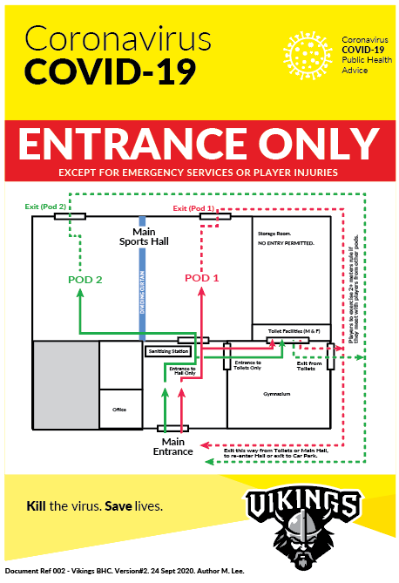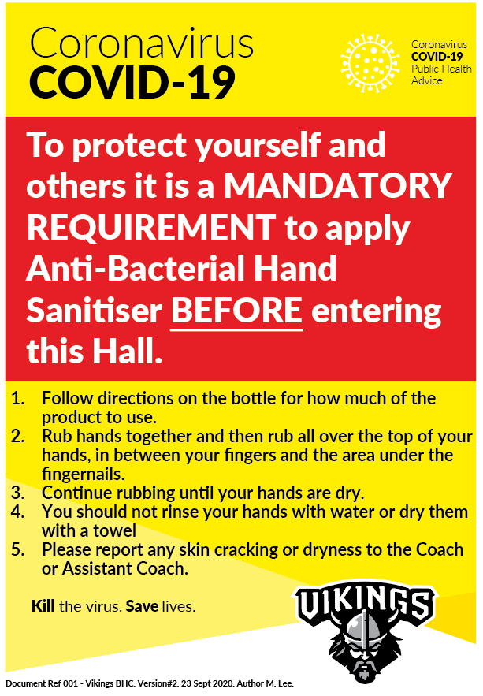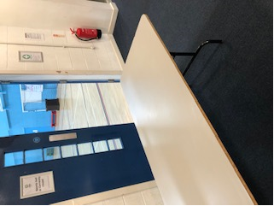

One-way system indicated with floor arrows ◄

A table will be placed immediately before the entrance and will contain relevant signage and anti-bacterial alcohol gel dispensers ▼

**Appendix II****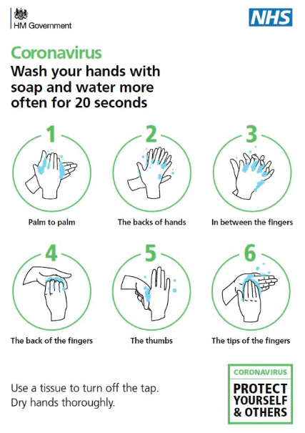**

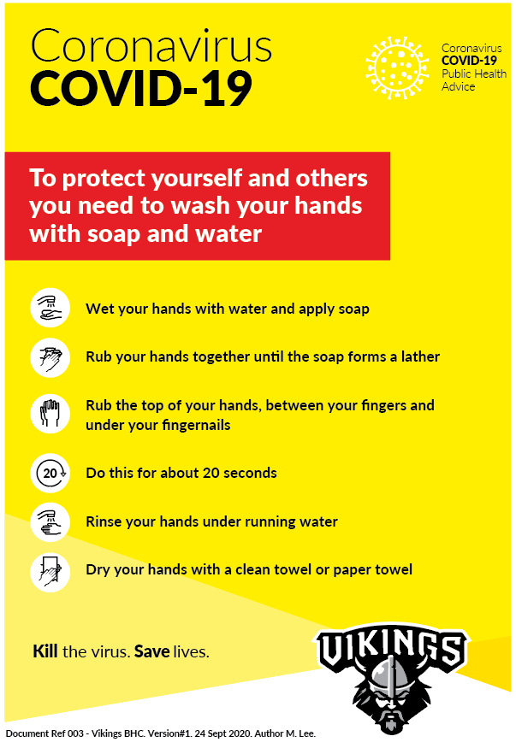

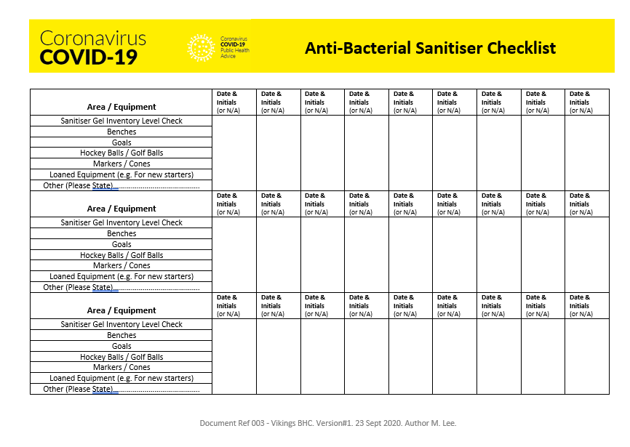**Appendix III**

**Appendix IV**

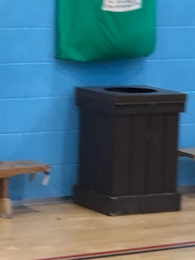

Designated waste bins are located in the main hall.

There is one bin per pod of 6 people.

◄

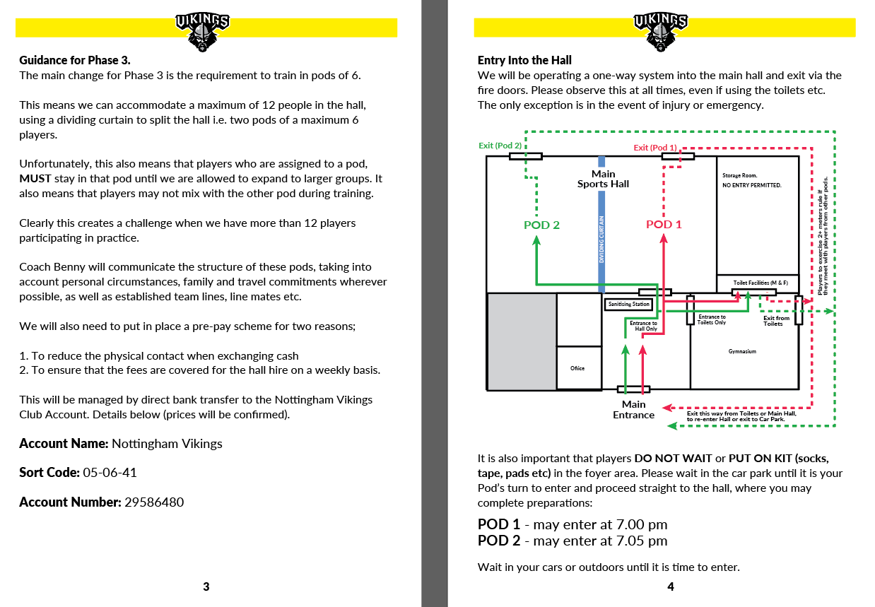**Appendix V** (Document may be updated from version below)

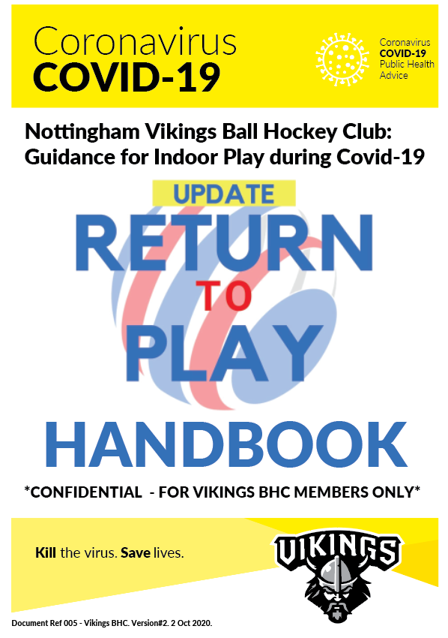

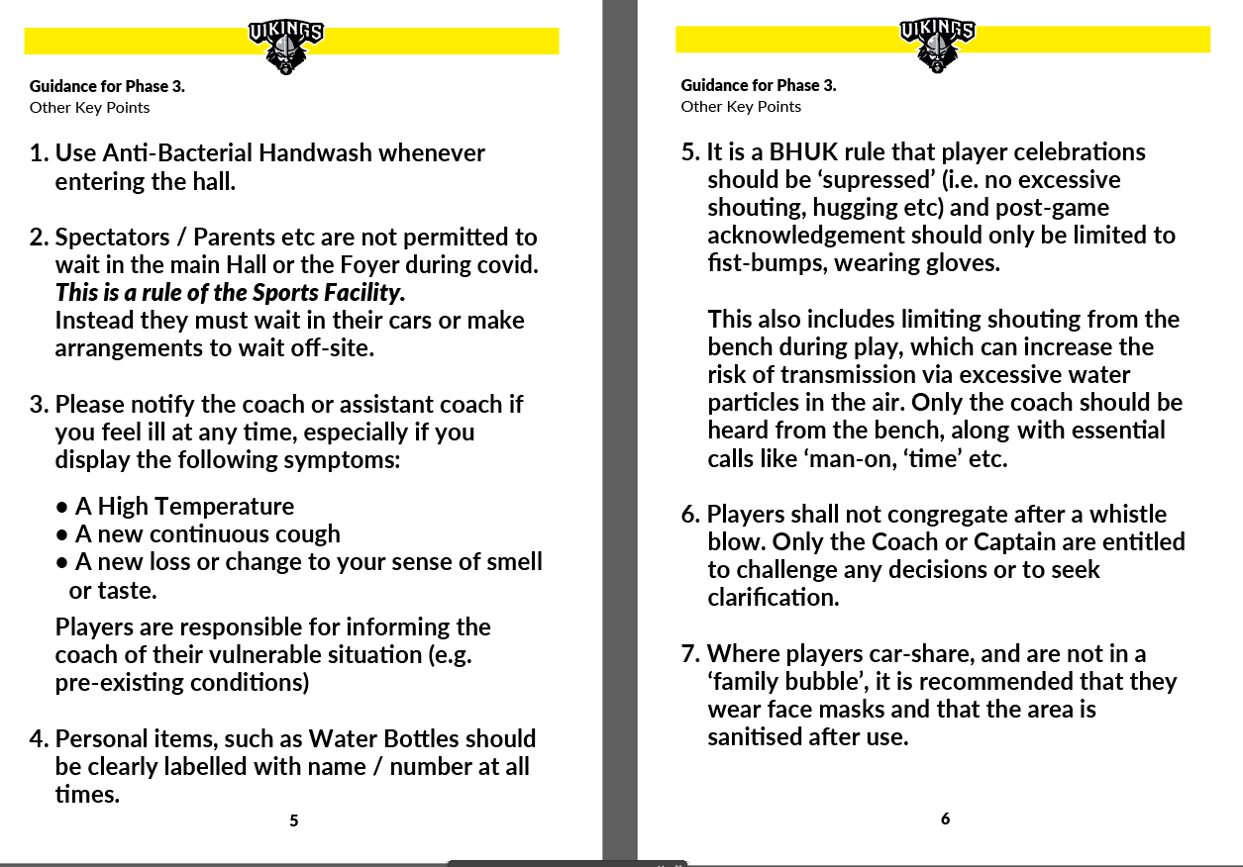

**Appendix VI**

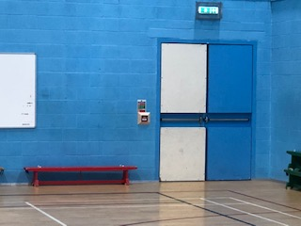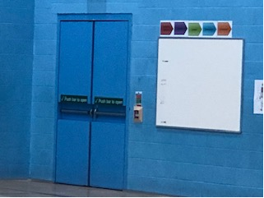

Fire doors will be opened at each end of the hall to ensure that there is adequate ventilation. This will apply during winters months and is actually desirable to provide some cool air for the players!

▼

**Appendix VII**

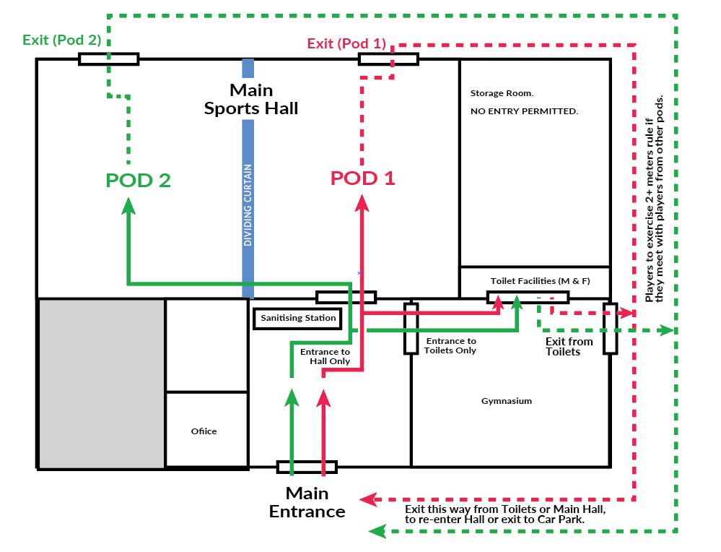

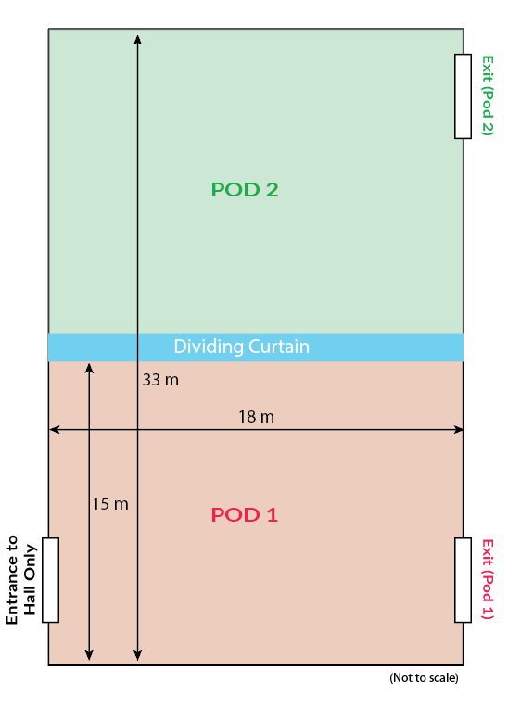**Appendix VIII**

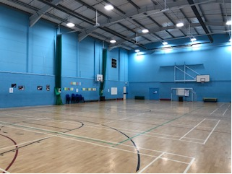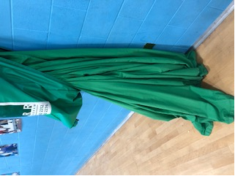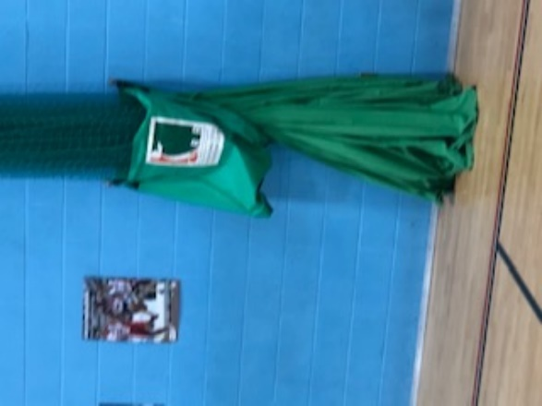

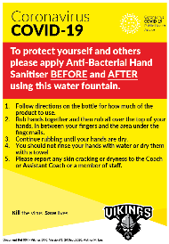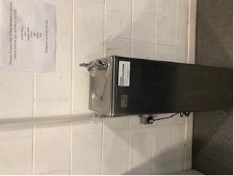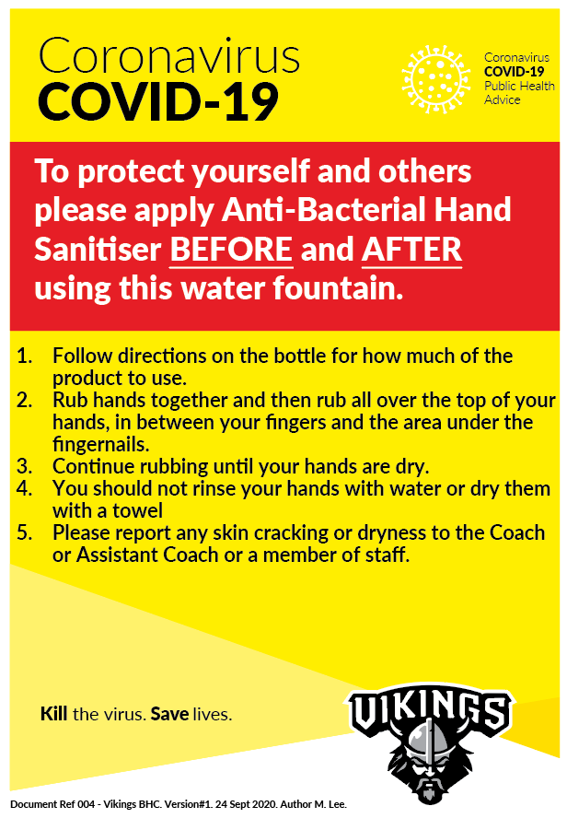**Appendix IX** **- PLEASE NOTE: This Fountain has been decommissioned by the Sports facility.**

**Appendix X**

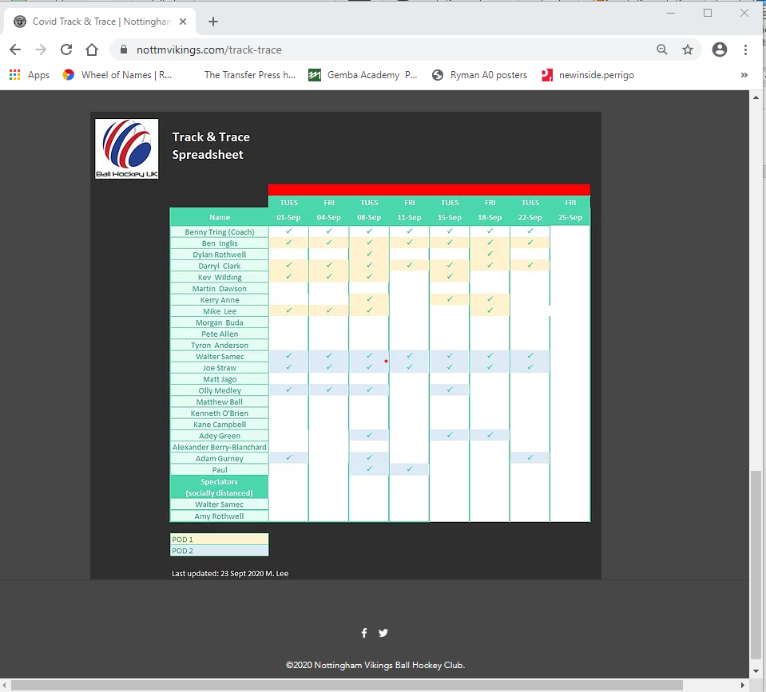Note: Player’s contact details are held confidentially by the Head Coach only.